NI VeriStand Engine Demo

Creating a TestStand Sequence Using the Custom NI VeriStand Steps for NI TestStand

1. Create a new sequence file and name it **NIVS Engine Demo.**

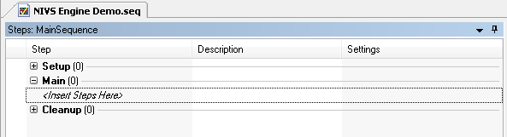

# Create a basic sequence file that deploys the Engine Demo example project, waits 20 seconds, then undeploys.

1. Configure TestStand to initialize VeriStand.
   1. Place an **Initialize VeriStand** step in the **Setup** section of the sequence file (found in the **NI VeriStand** section of the **Steps Types** pane). You will notice through this process that a VeriStand FileGlobal container is added to your **Variables** pane. The VeriStand FileGlobal is contains the various reference required to update channel values, get alarm status, etc. It also contains the project and system definition path, as well as the gateway IP address.

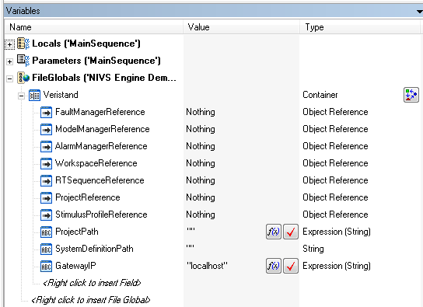

* 1. In the **Initialize VeriStand** tab of the **Initialize VeriStand** step, select the **Configure** **Gateway…** button.
  2. In the **Configure Gateway** dialog box that appears, set the **ProjectPath** to <Public Documents>\National Instruments\<NI VeriStand version>\Examples\Stimulus Profile\Engine Demo\Engine Demo.nivsproj using the **Browse…** button.

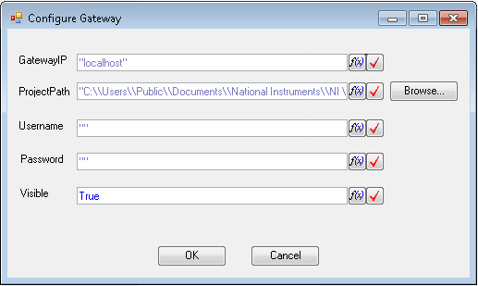

**NOTE:** String literals in TestStand expressions use a backslash as the escape character, similar to other programming languages like C/C++ and C#. Therefore, if you specify a path using a string literal in an expression, such as for the parameter value of a code module, you must use two backslash characters for each actual backslash the string value requires because TestStand interprets the first backslash character as escaping the character after it.

* 1. Select **OK** to close the dialog box.

1. Configure TestStand to wait 20 seconds.
   1. Place a **Wait** step in the **Main** section of the sequence file (found in the **Synchronization** section of the **Step** **Types** pane).
   2. In the **Wait Settings** tab, set the time to wait to 20.

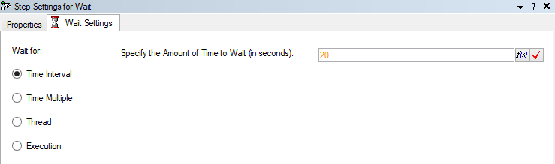

1. Configure TestStand to undeploy the project.
   1. Place a **Stop VeriStand** step in the **Cleanup** section of the sequence file.
2. Your sequence should now look similar to the one pictured below:

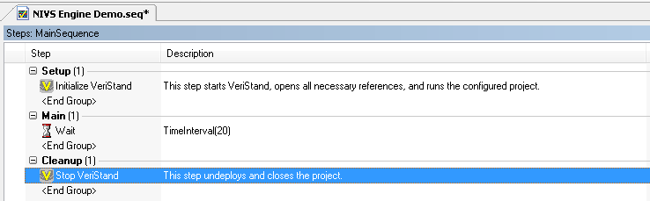

1. Execute a single pass of the test by selecting **Execute>>Single Pass** or selecting **Ctrl+F5**.
2. Save the sequence file.

# Read the Absolute Time of the deployed project.

1. Get the **Absolute Time** from the deployed project.
   1. Add a **Get Channel Value** (located in the **Channels** folder under **NI VeriStand** in the **Step Types** Pane) to the **Main** section of the sequence file after the **Wait** step.
   2. Rename the step to **Get Channel Value – Absolute Time**.
   3. Select the **Get Channel Value** tab in the step settings and select the **Configure Channel…** button.
   4. Select the **Absolute Time** channel and select **OK**.
2. Your sequence should now look similar to the one pictured below:

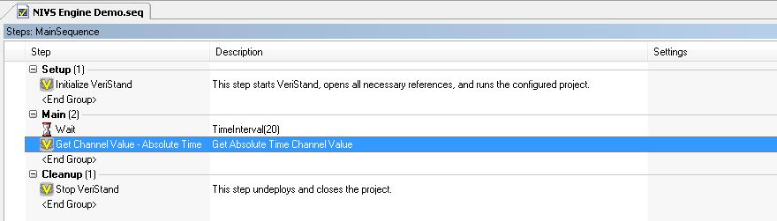

1. Execute a single pass of the test by selecting **Execute>>Single Pass** or selecting **Ctrl+F5**.
2. In the resulting report, notice that the **Absolute Time** has been added:

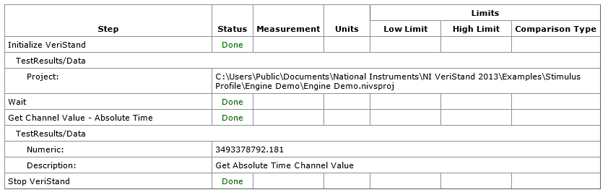

1. Save the sequence file.

# Run a RT Sequence Pass Fail Test for the deployed project.

1. Delete the **Wait** step from the sequence by selecting the step in the sequence and selecting **Delete**. We no longer need this step.
2. Document the **Get Channel Value – Absolute Time** step.
   1. Select a **Label** step and place it before the **Get Channel Value – Absolute Time** step in the sequence.
   2. Rename it to read **Get Absolute Time**.
   3. In the **Label** tab of the step settings, set the **Label Description** to state that the step is used to read the Absolute Time system channel.
3. Document that the sequence will be running theEngine Demo Advanced & Return Value stimulus profile.
   1. Select a **Label** step and place it after the **Get Channel Value – Absolute Time** step in the **Main** section of the sequence.
   2. Rename it to read **Run Engine Demo Advanced RT Sequence**.
   3. In the **Label** tab of the step settings, set the **Label Description** to state that the step is used to run the Engine Demo Advanced & Return Value RT sequence.
4. Add and configure the RT Sequence Pass Fail Test
   1. Place a RT Sequence Pass Fail Test (located in the **VeriStand Tests** folder under **NI VeriStand** in the **Step Types** Pane) after the **Run Engine Demo Advanced RT Sequence** label.
   2. In the **RT Sequence Pass Fail Test** tab of the step settings, select the **Configure RT Sequence…** button.
   3. In the **Configure Real Time** Sequence dialog that appears, use the **Browse…** button to set the **Sequence File Path** to <Public Documents>\National Instruments\<NI VeriStand version>\Examples\Stimulus Profile\Engine Demo\Stimulus Profiles\Engine Demo Advanced & Return Value\Engine Demo Advanced & Return Value.nivsseq.

NOTE: The sequence parameters are prepopulated with the configured default value. This can be changed by selecting the **Browse…** button in the **Select Channel** column.

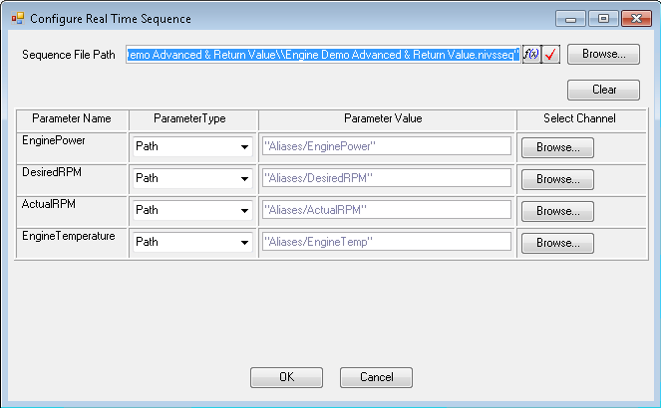

* 1. Select **OK** to close the dialog.

1. Your sequence should now look similar to the one pictured below:

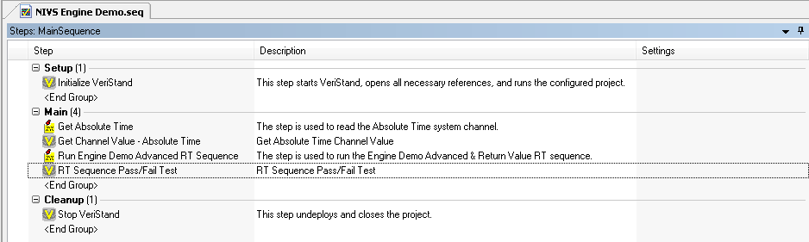

1. Execute a single pass of the test by selecting **Execute>>Single Pass** or selecting **Ctrl+F5**.
2. Notice that the **RT Sequence Pass/Fail Test** step has failed indicating that the sequence has failed.

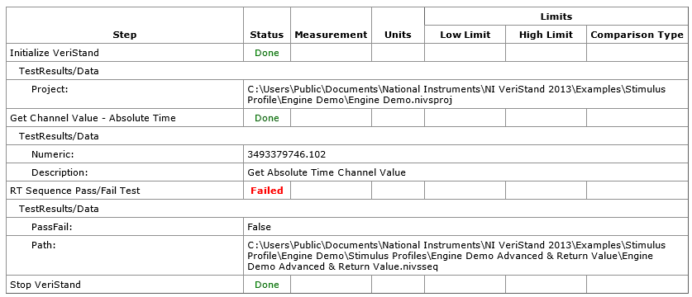

1. Save the sequence file.

# Get the rise time for the deployed project.

1. If it not already present in this location, place the Get Rise Time.nivsseq file in the <Public Documents>\National Instruments\<NI VeriStand version>\Examples\Stimulus Profile\Engine Demo\Stimulus Profiles directory. This file will be used to compute the time it takes for the Actual RPM to reach the Commanded RPM.
2. Document that the Get Rise Time sequence will be running.
   1. Select a **Label** step and place it after the **RT Sequence Pass/Fail Test** step in the **Main** section of the sequence.
   2. Rename it to read **Run Get Rise Time RT Sequence**.
   3. In the **Label** tab of the step settings, set the **Label Description** to state that the step is used to run the Get Rise Time RT sequence.
3. Run the Get Rise Time RT sequence.
4. Place a **RT Sequence Action** step after the **Run Get Rise Time RT Sequence** step in the **Main** section of the sequence.
5. In the **RT Sequence Action** tab of the step settings select the **Configure RT Sequence…** button.
6. In the **Configure Real Time Sequence** dialog that appears set the **Sequence File Path** to <Public Documents>\National Instruments\<NI VeriStand version>\Examples\Stimulus Profile\Engine Demo\Stimulus Profiles\Get Rise Time.nivsseq using the **Browse…** button.

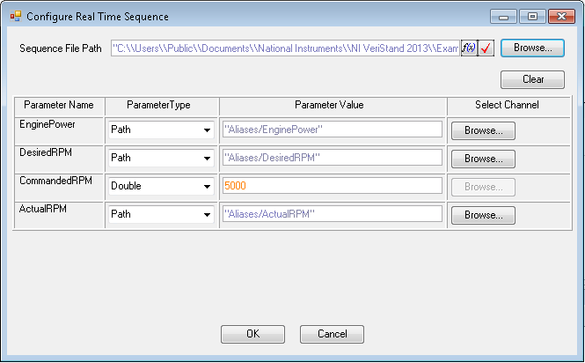

1. Select **OK** when finished.
2. Return the rise time to the user using a **Message Popup** step.
   1. Place a **Message Popup** step after the **RT Sequence Action** step.
   2. Rename the step to **Return Rise Time**.
   3. In the **Text and Buttons** tab of the step, set the **Message Expression** to “The Rise Time is “ & Str(RunState.PreviousStep.Result.VeriStand.Returnval) & “ seconds.”

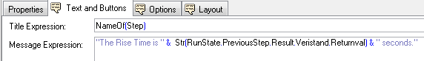

1. Your sequence should now look similar to the one pictured below:

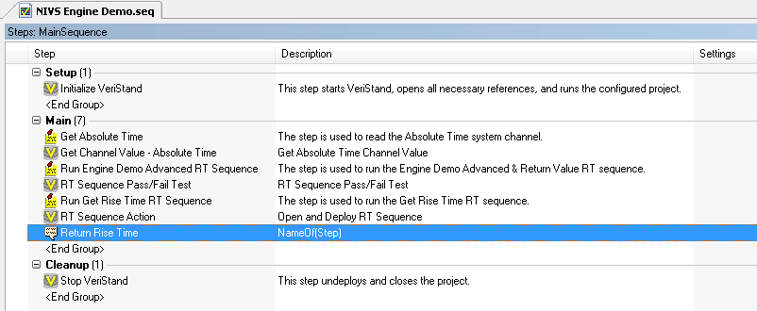

1. Execute a single pass of the test by selecting **Execute>>Single Pass** or selecting **Ctrl+F5**.
2. Notice that the **RT Sequence Action** step reports the return value of the real-time sequence.

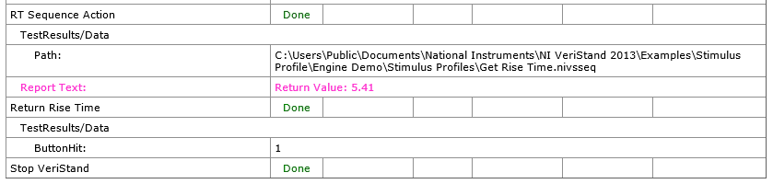

1. Save the sequence file.